Name _____________________________ Date _______________
Aquatic Health of WNY Ecosystems
Background: Lake Erie and Lake Ontario are the two “lower” Great Lakes. All of the water as well as the pollutants it contains, must pass through the entire Great Lakes system before it reaches them. In addition, the Niagara River watershed has historically been a dumping ground for many chemical companies. The old slogan, “the solution to pollution is dilution” rang true in our area for many decades. Recently, we have become more aware of the damage that our past actions have caused and we are beginning to see a turnaround in our area bodies of water. However, numerous chemicals continue to end up in our water from many point and non-point sources that present an ongoing issue for all.
Objectives:
- Use sensors in a hydrolab to take measurements of various water samples in area bodies of water in the Tonawanda and Grand Island area
- Construct bar graphs based on the data compiled
Materials:
- Hydrolab containing the following sensors: Depth, temperature, pH, dissolved oxygen, turbidity
- Field notebook to record data
Procedure:
- Predicting certain data about the locations prior to the samples being collected
- Record collected data
- Graph data for each location
- Answer conclusion and extension questions based on the lab

Reference:
pH Scale: The pH scale measures how acidic or basic a substance is. The pH scale ranges from 0 to 14. A pH of 7 is neutral. A pH less than 7 is acidic. A pH greater than 7 is basic.
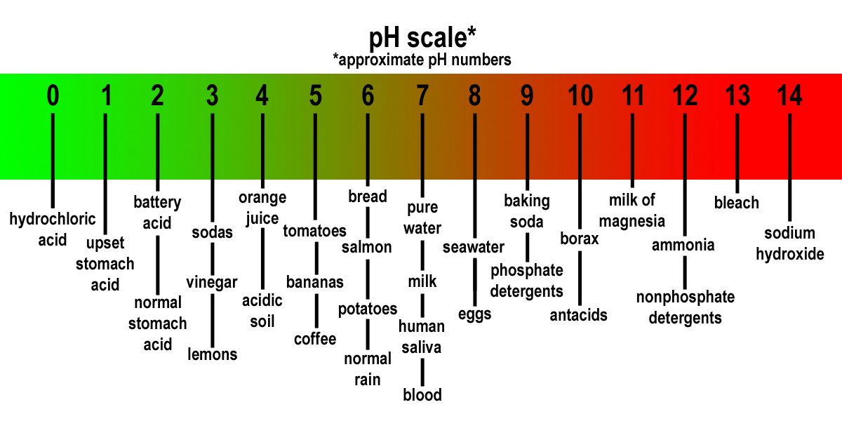

Dissolved Oxygen:
The measure of how much oxygen is dissolved in water. Although water molecules contain an oxygen atom, this oxygen is not what is needed by aquatic organisms living in natural waters. Rapidly moving water tends to contain a lot of dissolved oxygen, whereas stagnant water contains less.

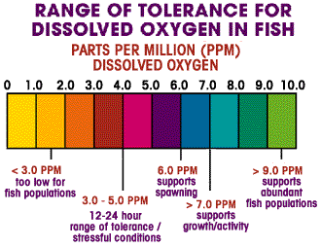

Turbidity:
Turbidity is the relative clarity of a liquid. The higher the intensity of scattered light, the higher the turbidity. During a rainstorm, particles from the surrounding land are washed into the river making the water a muddy brown color, indicating water that has higher turbidity values. Also, during high flows, water velocities are faster and water volumes are higher, which can more easily stir up and suspend material from the stream bed, causing higher turbidities.
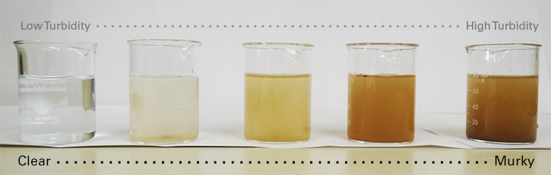

Pre-lab questions: Predict which Tonawanda and Grand Island stations will have the lowest and highest pH, temperature, dissolved oxygen and turbidity.
Tonawanda Locations: Two Mile Creek, Niagara River (Nia-Wanda Park), Eric Canal, Ellicott Creek
Grand Island Locations: Niagara River (South GI Bridge), Beaver Island Marina, Big 6, Spicer Creek

Lowest pH: ________________ Highest pH: ____________________
Lowest temperature: ________________ Highest temperature: __________________
Lowest dissolved oxygen: _______________ Highest dissolved oxygen: _______________
Lowest turbidity:____________________ Highest turbidity: ________________

Data Collection:
Tonawanda Location Data:

Station #1 Two Mile Creek
Depth
Temperature
pH
Dissolved O₂
Turbidity

Station #2 Niagara River
Depth
Temperature
pH
Dissolved O₂
Turbidity

Station #3 Erie Canal
Depth
Temperature
pH
Dissolved O₂
Turbidity

Station #4 Ellicott Creek
Depth
Temperature
pH
Dissolved O₂
Turbidity

Grand Island Location Data:
Station #1 Niagara River (South GI Bridge)
Depth
Temperature
pH
Dissolved O₂
Turbidity

Station #2 Beaver Island Marina
Depth
Temperature
pH
Dissolved O₂
Turbidity

Station #3 Big 6
Depth
Temperature
pH
Dissolved O₂
Turbidity

Station #4 Spicer Creek

Depth
Temperature
pH
Dissolved O₂
Turbidity

Graphing: Construct a bar graph for each of the following sets of data: temperature, pH and dissolved oxygen, and turbidity for each of the stations. Label the dependent and independent variables on the x and y axes of each graph.

Temperature

pH

Dissolved Oxygen

Turbidly

Post-lab questions:
- Did the data support any of your predictions? ________ Explain.

- Which station appears to be the healthiest? _____________________ Why do you think this is the case?

- Which station appears to be the dirtiest? ________________________ Why do you think this is the case?

- What species of fish found in various locations of the Niagara River would probably not be found in Ellicott Creek or Two Mile Creek? _________________________________________________________________ _______________________________________________________________________________________
Why? __________________________________________________________________________________

Extension: There are numerous contaminants found in found in bodies of water including those that can make the water system harmful even though the other data suggest it may be healthy. List three other contaminants and explain the problems that each cause within the water as well as within the human body.
Contaminate | Water Problems | Human Health Problems

